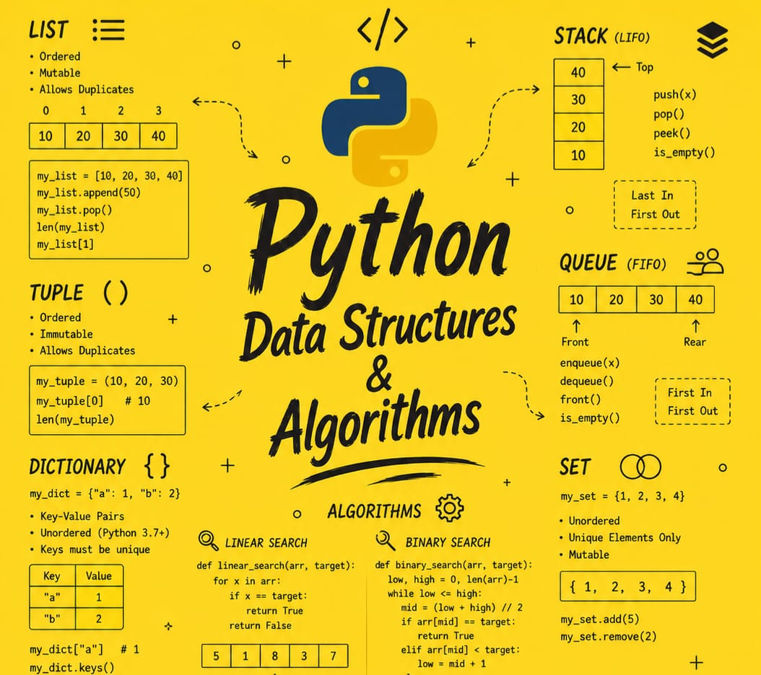

Python Data Structures & Algorithms

By Jawad Jammoul

